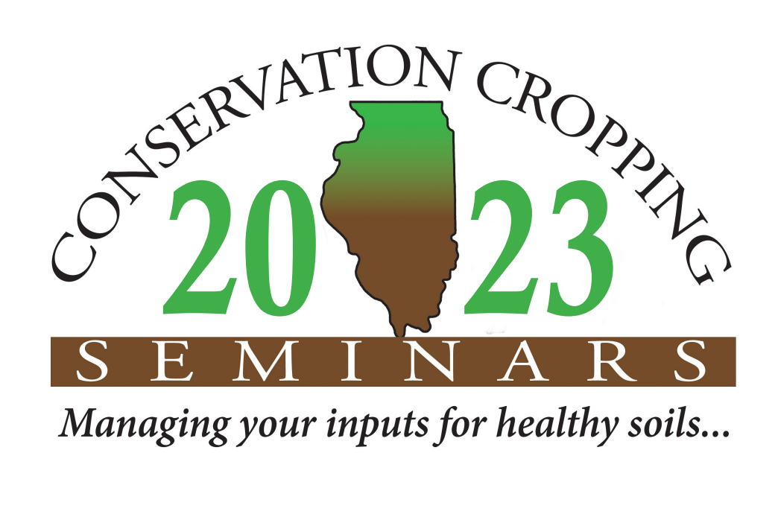
NEWS
RELEASE

For Immediate Release: December 28, 2022 Contact: Paige.buck@usda.gov 217-353-6606
Attention Illinois Farmers! The annual Conservation Cropping Seminar will be taking place January 18th, 2023 with both virtual and in-person options. The event will be held from 9am-3pm with the in-person attendees meeting at the Illinois Department of Ag Building in Springfield, IL. The in-person event registration is only $25 (lunch included) and the virtual access is only $15. This event will count for 4.5 soil & water CCA CEUs and 1.0 nutrient management CCA CEU.
This event is an excellent way to learn more on how to improve soil health, cover crops, adopt new technologies, improve root health, manage nutrients, and hear the latest on agronomic research. There will be a question & answer session with an IL farmer panel, as well as helpful resources to access.
Topics & speakers for this year include:
- Corn Yield Gap Reduction Strategies for Cover Crop Systems - Dr. Shalamar Armstrong-Purdue University
- Making Money with Soil Health - Mitchell Hora-Continuum Ag
- Using Stewardship Practices in Indiana to Improve On-Farm Sustainability - Besty Bower, Agronomist-Ceres Solutions Cooperative
- Roots of Climate Mitigation - -Philip Benfey-High Fidelity Technologies
- Climate-Smart Agriculture in Cropping Systems: Initiatives for Practices and Systems - Dr. Michael Woods, Manager-Division of Natural Resources, IL Dept. of Agriculture
- Farmer panel speakers include: Lee Curby (Sangamon County), Andrea Hazzard (Winnebago County), and Monte Botton (Henry County)
This event is organized and made possible with involvement and support of IL Dept. of Agriculture, USDA’s Natural Resources Conservation Service, American Farmland Trust, the Illinois Stewardship Alliance, IL Environmental Protection Agency, IL Sustainable Ag Partnership, and local Soil & Water Conservation Districts. Look for newspaper stories, ads, tweets, Facebook posts and other reminders!
Don’t miss this opportunity to learn from the experts and network with other conservation-minded attendees. Register by January 11th at www.ccswcd.com to learn more and reserve your spot. In-person spots are limited so sign-up today!
###

